***Deploying 5 node Cloudera CDH cluster along with Kerberos HA***

**Pre-Requisites for deploying ClouderaCDH cluster on OSlevel:**

Before installing CDH in our server, we’ve to make the below configuration changes in OS level for successful installation.

* **Disable SELINUX**

“Security-Enhanced Linux (**SELinux**) is a Linux kernel security module that provides a mechanism for supporting access control security policies”

If SElinux is enabled, then cloudera server installation will fail in the server.

To disable Selinux temporarily:

# echo 0 > /selinux/enforce

To disable Selinux, edit the selinux config file and set “selinux=disabled”  
Requires server restart

# vi /etc/sysconfig/selinux

selinux=disabled

To check the status of selinux:  
#sestatus

* VM swappiness

vm.swappiness is a Linux kernel parameter that controls how aggressively memory pages are swapped to disk. It can be set to a value between 0-100; the higher the value, the more aggressive the kernel is in seeking out inactive memory pages and swapping them to disk.

To check VM swappiness value:

cat /proc/sys/vm/swappiness

On most systems, it is set to 30 by default. This is not suitable for Hadoop cluster nodes, because it can cause processes to get swapped out even when there is free memory available. This can affect stability and performance, and may cause problems such as lengthy garbage collection pauses for important system daemons.

Cloudera recommends that you set this parameter to 10 or less;

# vi /etc/sysctl.conf

vm.swappiness=10

* Hostname resolution

If you’re not using any DNS server, then ensure that your hostname details are updated with fqdn in /etc/hosts file.

* In fstab, mount disks with “noatime” option as we don’t the disks to store the blocks accessed time in memory.

# cat /etc/fstab

/dev/sda2 /hadoop ext3 noatime,defaults 0 0

* Most Linux platforms supported by CDH 5 include a feature called transparent hugepage compaction which interacts poorly with Hadoop workloads and can seriously degrade performance.

To disable THP, add the below entry in /etc/rc.local file

# vi /etc/rc.local

echo 'never' > /sys/kernel/mm/redhat_transparent_hugepage/defrag

**Cloudera manager and CDH installation using Parcels:**

**1.Establish Your Cloudera Manager Repository Strategy**

Download the repository from given link using wget

wget <https://archive.cloudera.com/cm5/redhat/7/x86_64/cm/cloudera-manager.repo>

move it into /etc/yum.repos.d/

sudo mv /home/ec2-user/cloudera-manager.repo /etc/yum.repos.d/

run “yum update”

U can check added repo using “yum repolist” command.

**2.Install the Oracle JDK on the Cloudera Manager Server Host**

After downloading and editing the repo or list file, install the JDK as follows:

sudo yum install oracle-j2sdk1.7

**3.Install and Configure External Postgresql Database**

Postgesql database package is included in base Redhat OS repos , so we can download and install it using below command.

sudo yum install postgresql-server postgresql-contrib

***Initialize your Postgres database and start PostgreSQL:***

sudo postgresql-setup initdb

sudo systemctl start postgresql

***Configure PostgreSQL to start on boot:***

sudo systemctl enable postgresql

***Configure PostgreSQL***

**Secure the Postgres Users**By default, PostgreSQL will create a Linux user named postgres to access the database software.

Change the postgres user’s Linux password:

sudo passwd postgres

Issue the following commands to set a password for the postgres database user. Be sure to replace newpassword with a strong password and keep it in a secure place.

su - postgres

psql -d template1 -c "ALTER USER postgres WITH PASSWORD 'newpassword';"

By default, PostgreSQL only accepts connections on the loopback interface. You must reconfigure PostgreSQL to accept connections from the Fully Qualified Domain Name (FQDN) of the hosts hosting the management roles. If you do not make these changes, the management processes cannot connect to and use the database on which they depend.

Enable MD5 authentication. Edit pg_hba.conf, which is usually found in /var/lib/pgsql/data or /etc/postgresql/8.4/main. Add the following line:

host all all <ip of db server host>/32 md5

If the default pg_hba.conf file contains the following line:

host all all <ip of db server host>/32 ident

then the host line specifying md5 authentication shown above must be inserted before this ident line. Failure to do so may cause an authentication error when running the scm_prepare_database.sh script. You can modify the contents of the md5 line shown above to support different configurations. For example, if you want to access PostgreSQL from a different host, replace 127.0.0.1 with your IP address and update postgresql.conf, which is typically found in the same place as pg_hba.conf, to include:

listen_addresses = '*'

Configure settings to ensure your system performs as expected. Update these settings in the /var/lib/pgsql/data/postgresql.conf or /var/lib/postgresql/data/postgresql.conf file.

shared_buffers - 256MB

wal_buffers - 8MB

checkpoint_segments - 16

checkpoint_completion_target - 0.9

**Start or restart the PostgreSQL database:**

$ sudo service postgresql restart

**Preparing a Cloudera Manager Server External Database**

If you are not using the Cloudera Manager installer, create a database for the Cloudera Manager Server. The database name, username, and password can be any value. Record the names chosen because you will need them later when running the [scm_prepare_database.sh](https://www.cloudera.com/documentation/enterprise/5-8-x/topics/cm_ig_installing_configuring_dbs.html#concept_i2r_m3m_hn__section_qjj_pyp_bm) script.

*postgres=# CREATE ROLE scm LOGIN PASSWORD 'scm';*

*postgres=# CREATE DATABASE scm OWNER scm ENCODING 'UTF8';*

Run the [scm_prepare_database.sh](https://www.cloudera.com/documentation/enterprise/5-8-x/topics/cm_ig_installing_configuring_dbs.html#concept_i2r_m3m_hn__section_qjj_pyp_bm) script on the host where the Cloudera Manager Server package is installed:

Installer or package install

*/usr/share/cmf/schema/scm_prepare_database.sh database-type [options] database-name username password*

**Creating Databases for Activity Monitor, Reports Manager, Hive Metastore Server, Sentry Server,oozie**

*Connect to PostgreSQL*:

*$ sudo -u postgres psql*

*postgres=# CREATE ROLE user LOGIN PASSWORD 'password';*

*postgres=# CREATE DATABASE databaseName OWNER user ENCODING 'UTF8';*

Replace User , Database name and password appropriate values.

**Create the Oozie User and Oozie Database**

*postgres=# CREATE ROLE oozie LOGIN ENCRYPTED PASSWORD 'oozie'*

*NOSUPERUSER INHERIT CREATEDB NOCREATEROLE;*

CREATE ROLE

*postgres=# CREATE DATABASE "oozie" WITH OWNER = oozie*

*ENCODING = 'UTF8'*

*TABLESPACE = pg_default*

*LC_COLLATE = 'en_US.UTF-8'*

*LC_CTYPE = 'en_US.UTF-8'*

*CONNECTION LIMIT = -1;*

CREATE DATABASE

Exit from postgres database:

*postgres=# \q*

**Configure PostgreSQL to Accept Network Connections for the Oozie User**

Edit the postgresql.conf file and set the listen_addresses property to *, to make sure that the PostgreSQL server starts listening on all your network interfaces. Also make sure that the standard_conforming_strings property is set to off.

Edit the PostgreSQL data/pg_hba.conf file as follows:

host oozie oozie 0.0.0.0/0 md5

**Install the Cloudera Manager Server Packages**

*sudo yum install cloudera-manager-daemons cloudera-manager-server*

**Start the Cloudera Manager Server**

Run this command on the Cloudera Manager Server host:

*sudo service cloudera-scm-server start*

**Start and Log into the Cloudera Manager Admin Console**

The Cloudera Manager Server URL takes the following form http://Server host:port, where Server host is the fully qualified domain name or IP address of the host where the Cloudera Manager Server is installed, and port is the port configured for the Cloudera Manager Server. The default port is 7180.

Login to the Cloudera Manager console using

Username: admin

Password: admin

(later u can change these credentials)

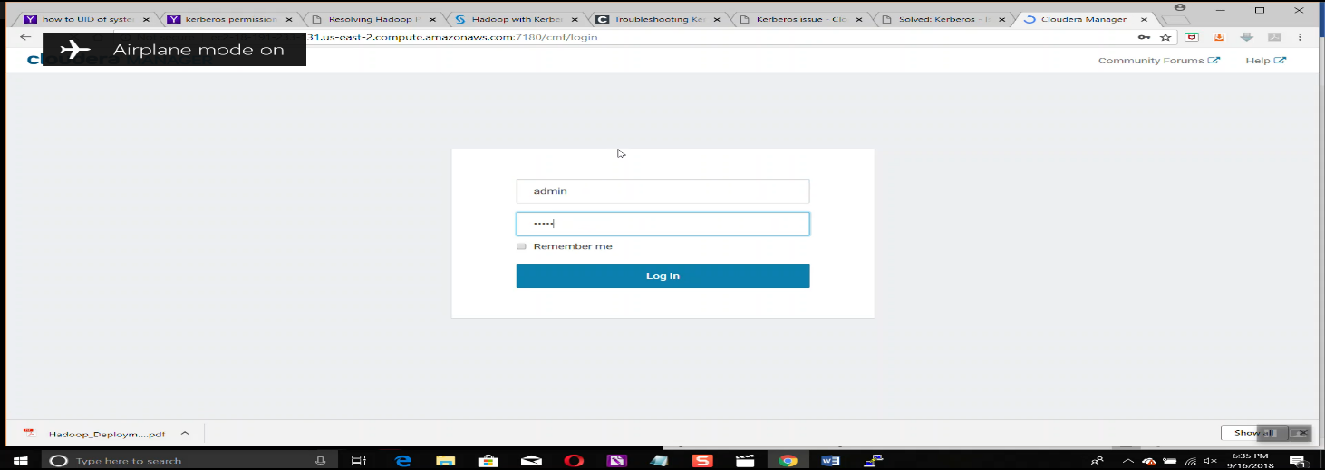

**Choose Cloudera Manager Edition:**

Cloudera Enterprise with one of the following license types:

Basic Edition

Flex Edition

Enterprise Data Hub Edition

**Choose Cloudera Manager Hosts**

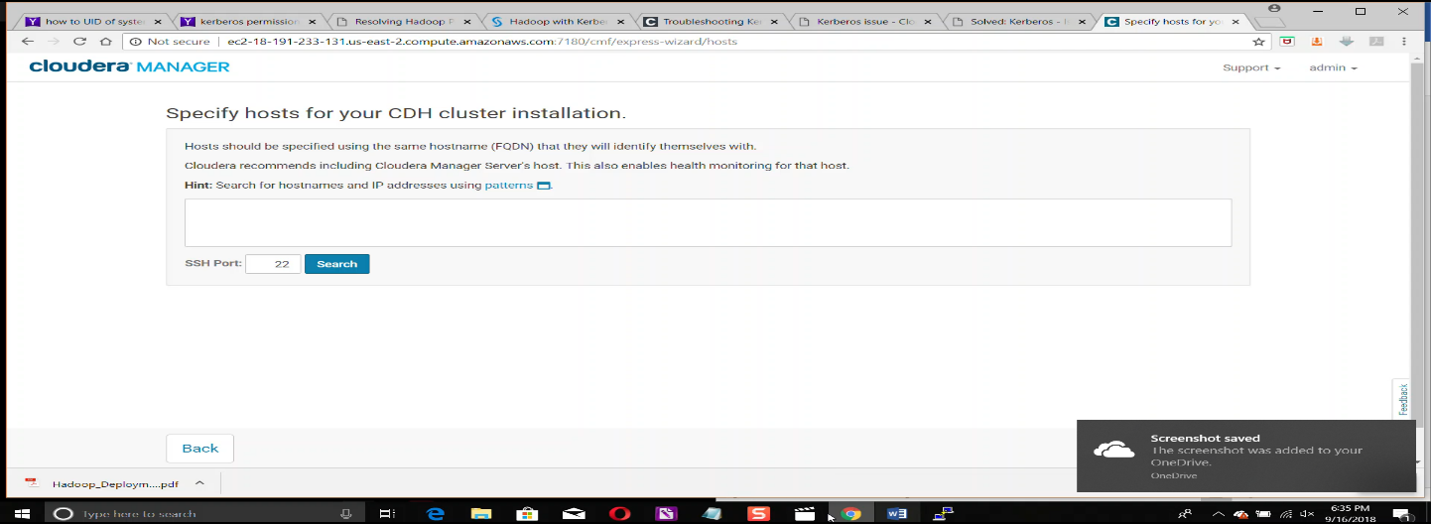

Here we need to specify the host IP addresses where we want install clouderamanager agent and CDH services.

**Choose the Software Installation Type and Install Software:**we can select either parcels or packages to install. If we want to specified version of parcel we click on more options and then we can replace {latest supported} with our specified version.

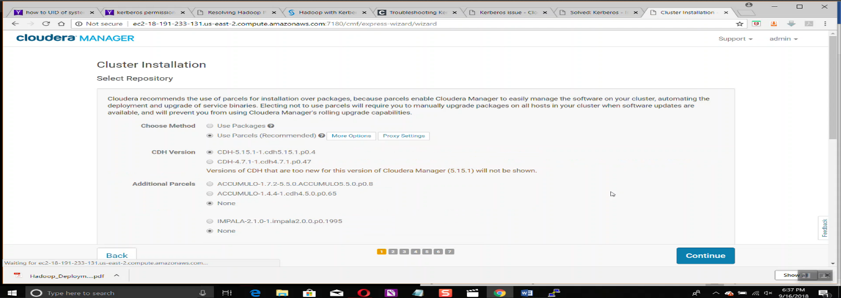

**Accept JDK licence and installing Java unlimited strength policy files:**

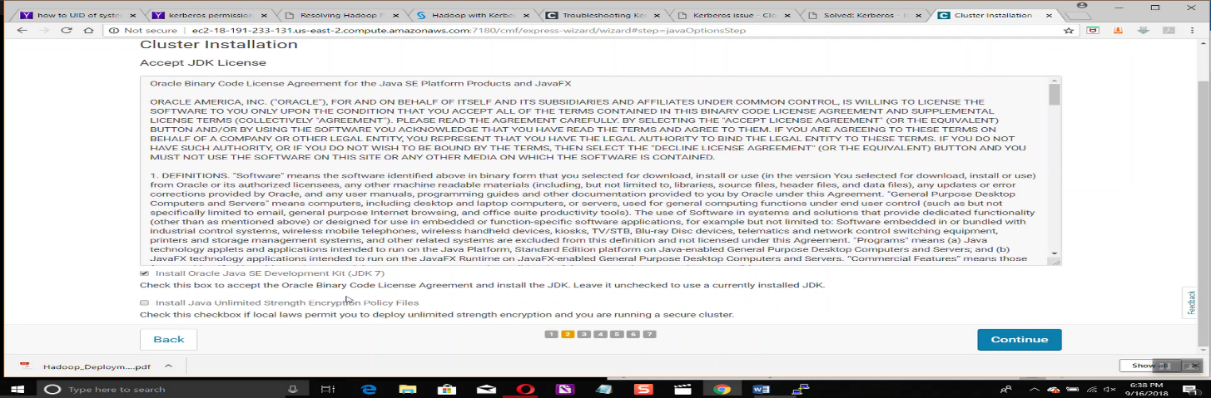

**Entering Login credentials for all hosts:**

On all hosts that we want install cloudera cdh , username in all hosts have to be same:

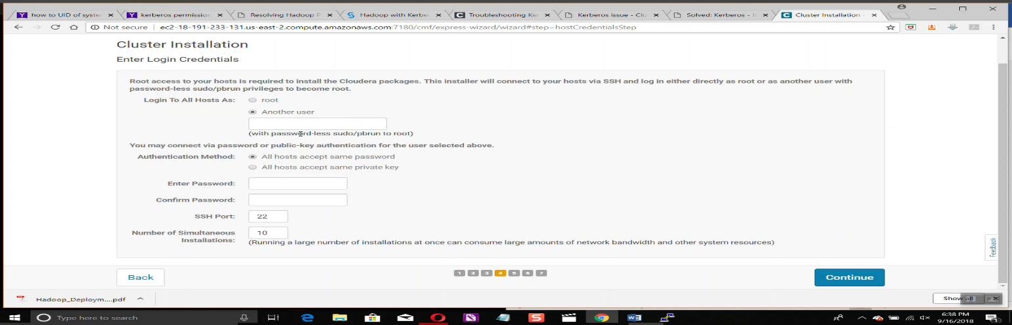

After Clicking on continue agent installation will be started: cloudera manager server will distribute java and cloudera manager agent packages and install them automatically.

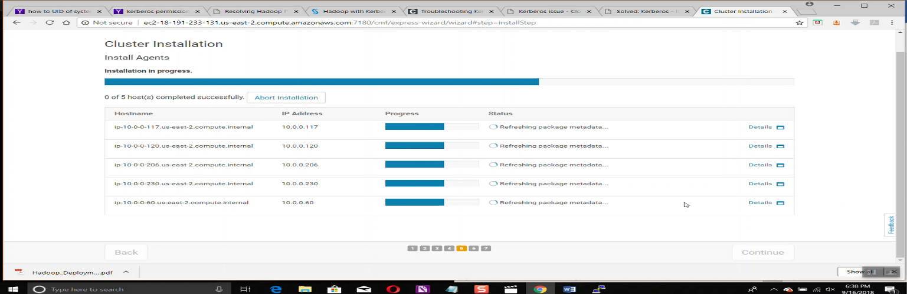

Next it will distribute,unpack and activate parcels of cdh on all hosts so that they will be ready for installation.

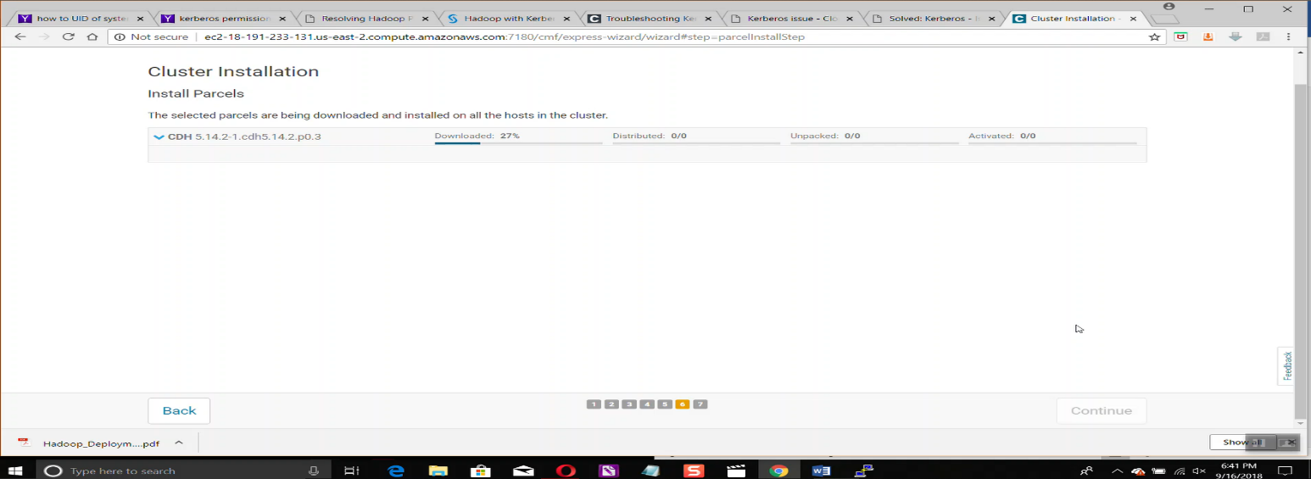

In next step cloudera manager server will inspect all hosts using host inspector for checking recommandations:

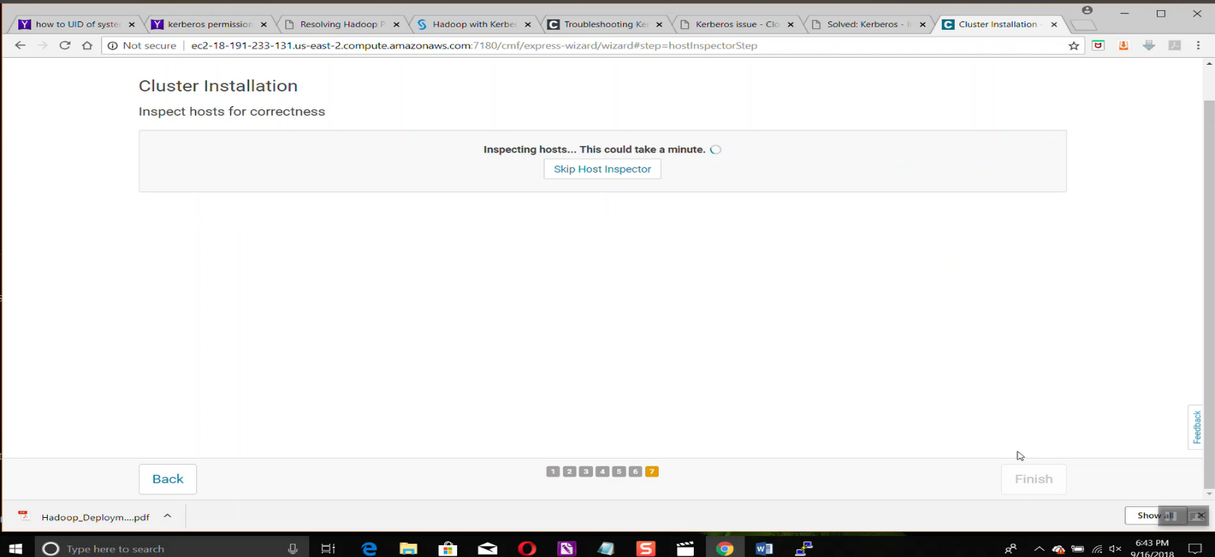

**Add Services**: now we need to setup cluster services which we need to install , there will be several combination we can select according our requirement , if none mactches we can select custom services:

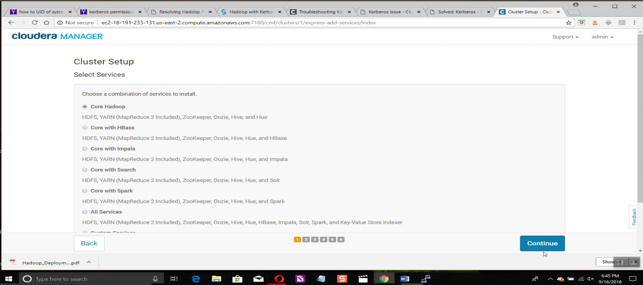

**Assigning roles for hosts**: in next step we have to assign roles for each and every host so that the services will be installed accordingly,

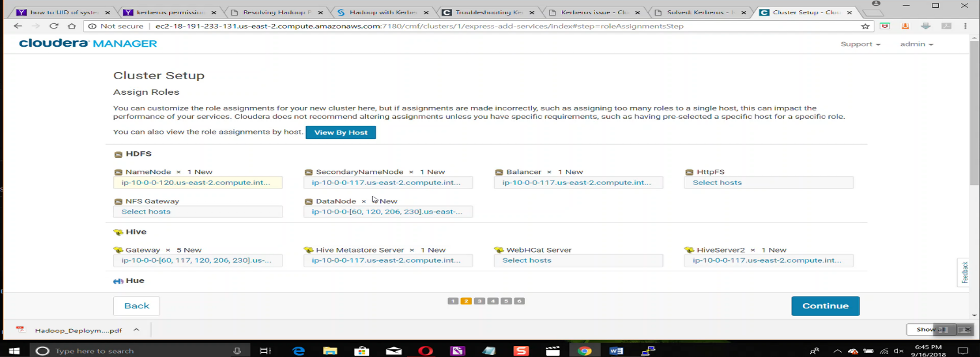

**Configure Database Settings:** Configure database connections by specifying database type , name, user and password after specifying we can test database connections by clicking on Test Connection tab.

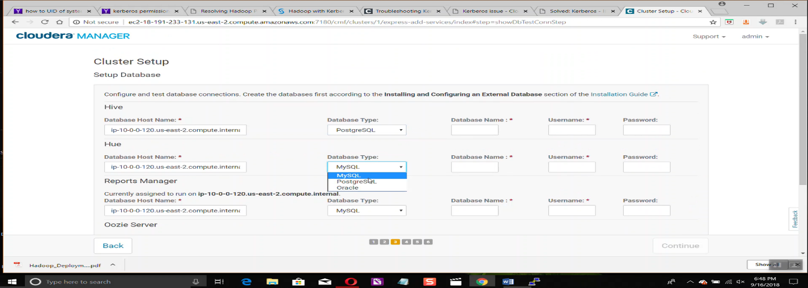

**Review Configuration Changes and Start Services:** in next step we can review configuration changes if any and do the configuration changes based on the requirement.

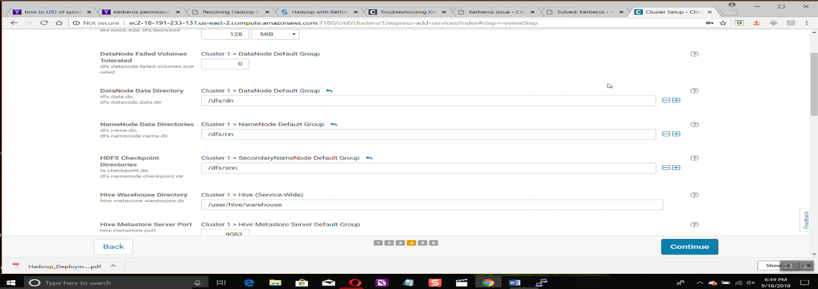

After clicking on continue it will execute start command for all services and all the services will be started accordingly if there is no error in configurations . if there is then the concerned service wont get start and u can find role log files in which we can check for the problem causing error and we can trouble shoot accordingly.

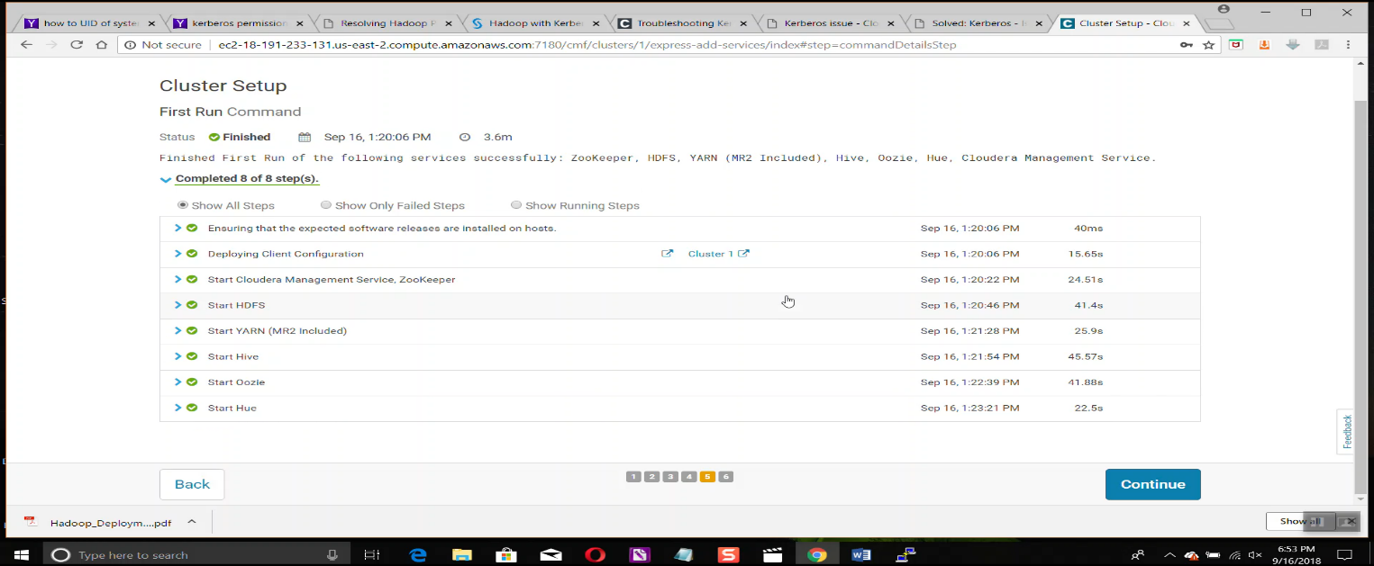

**Cloudera Manager UI:**

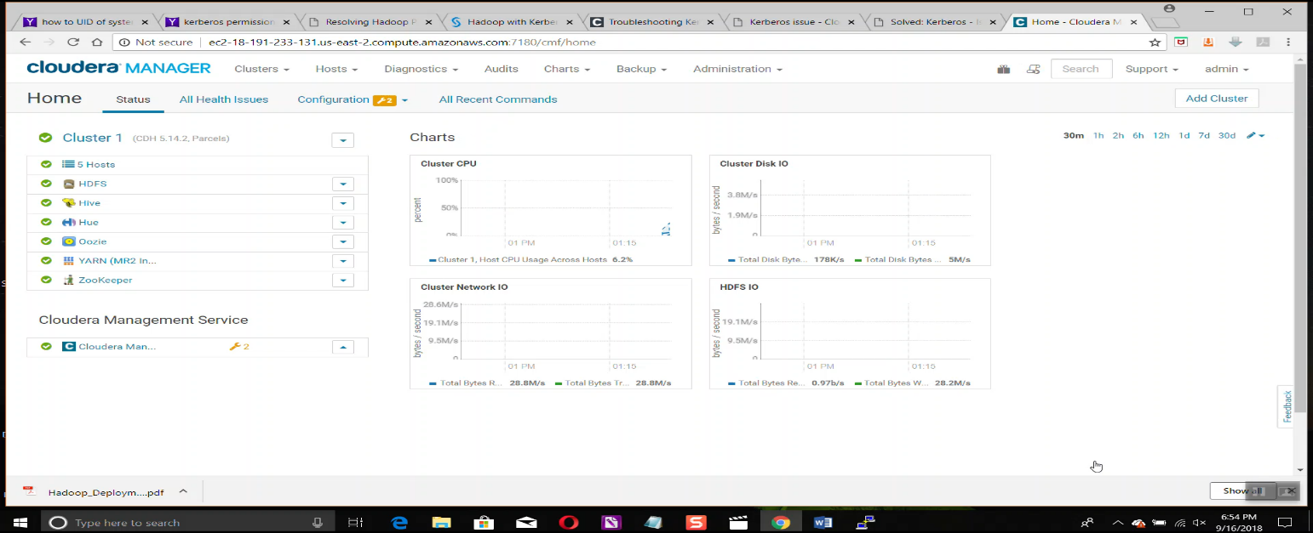

**Enabling Kerberos on Cloudera CDH:**

**Installing & Configuring KDC Server:**

*yum -y install krb5-server krb5-libs*

**Primary configuration file is 'krb5.conf':**

Ensure the default realm is set your domain name in capital case

Sample '/etc/krb5.conf'

# Configuration snippets may be placed in this directory as well

includedir /etc/krb5.conf.d/

[logging]

default = FILE:/var/log/krb5libs.log

kdc = FILE:/var/log/krb5kdc.log

admin_server = FILE:/var/log/kadmind.log

[libdefaults]

dns_lookup_realm = false

ticket_lifetime = 24h

renew_lifetime = 7d

forwardable = true

rdns = false

default_realm = TESTCLUSTER.COM

default_ccache_name = KEYRING:persistent:%{uid}

[realms]

TESTCLUSTER.COM = {

kdc = ip-10-0-0-4.us-east-2.compute.internal

kdc = ip-10-0-0-145.us-east-2.compute.internal

admin_server = ip-10-0-0-4.us-east-2.compute.internal

master_kdc = ip-10-0-0-4.us-east-2.compute.internal

}

[domain_realm]

.testcluster.com = TESTCLUSTER.COM

testcluster.com = TESTCLUSTER.COM

**Adjust /var/kerberos/krb5kdc/kdc.conf on the KDC:**

default_realm = TESTCLUSTER.COM

[kdcdefaults]

kdc_ports = 88

kdc_tcp_ports = 88

[realms]

TESTCLUSTER.COM = {

#master_key_type = aes256-cts

acl_file = /var/kerberos/krb5kdc/kadm5.acl

dict_file = /usr/share/dict/words

admin_keytab = /var/kerberos/krb5kdc/kadm5.keytab

supported_enctypes = aes256-cts:normal aes128-cts:normal des3-hmac-sha1:normal arcfour-hmac:normal camellia256-cts:normal camellia128-cts:normal des-hmac-sha1:normal des-cbc-md5:normal des-cbc-crc:normal

}

**Adjust /var/kerberos/krb5kdc/kadm5.acl on KDC:**

*/admin@TESTCLUSTER.COM *

cloudera-scm@TESTCLUSTER.COM *

**Creating KDC database to hold our sensitive Kerberos data:**

Create the database and set a good password which you can remember. This command also stashes your password on the KDC so you don’t have to enter it each time you start the KDC:

*kdb5_util create -r TESTCLUSTER.COM -s*

This command may take a while to complete based on the CPU power

**Now on the KDC create a admin principal and also cloudera-scm user:**

*[root@kdc ~]# kadmin.local*

*kadmin.local: addprinc* [*cloudera-scm@TESTCLUSTER.COM*](mailto:cloudera-scm@TESTCLUSTER.COM)

*kadmin.local: addpol admin*

*kadmin.local: addpol users*

*kadmin.local: addpol hosts*

*kadmin.local: exit*

**Let’s start the Kerberos KDC and kadmin daemons:**

*systemctl start krb5kdc.service*

*systemctl start kadmin.service*

*systemctl enable krb5kdc.service*

*systemctl enable kadmin.service*

## Setup kerberos client

yum -y install krb5-workstation

Transfer your /etc/krb5.conf (which got created from above command) from the KDC server to the client. Hop onto the client server, install the Kerberos client package and add some host principals:

Copy krb5.conf file from Kerberos server to all the Kerberos client hosts. So that they can recognize the realm and the server.

***After configuring Kerberos on OS level now go to Cloudera console and click on administration>> security >> enable Kerberos to configure Kerberos.***

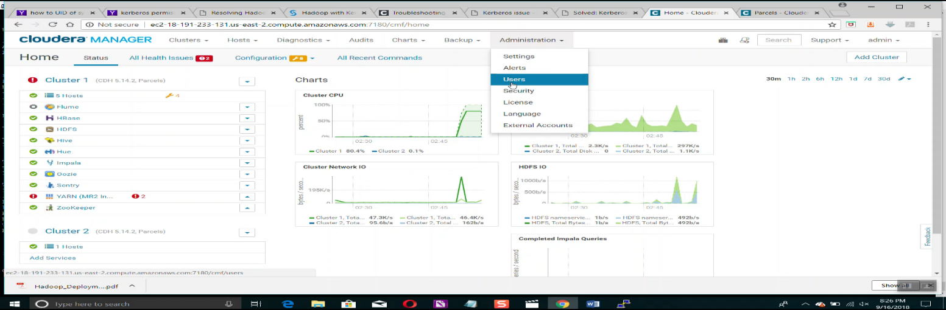

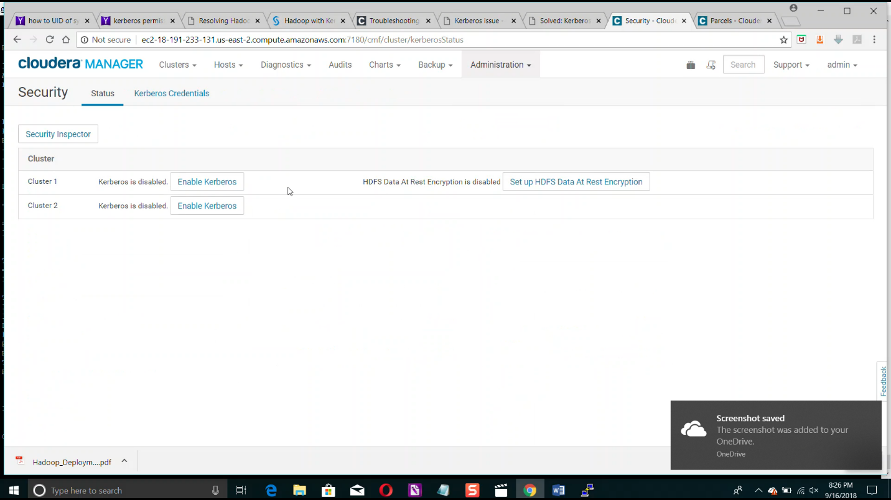

**Specify information about KDC**:

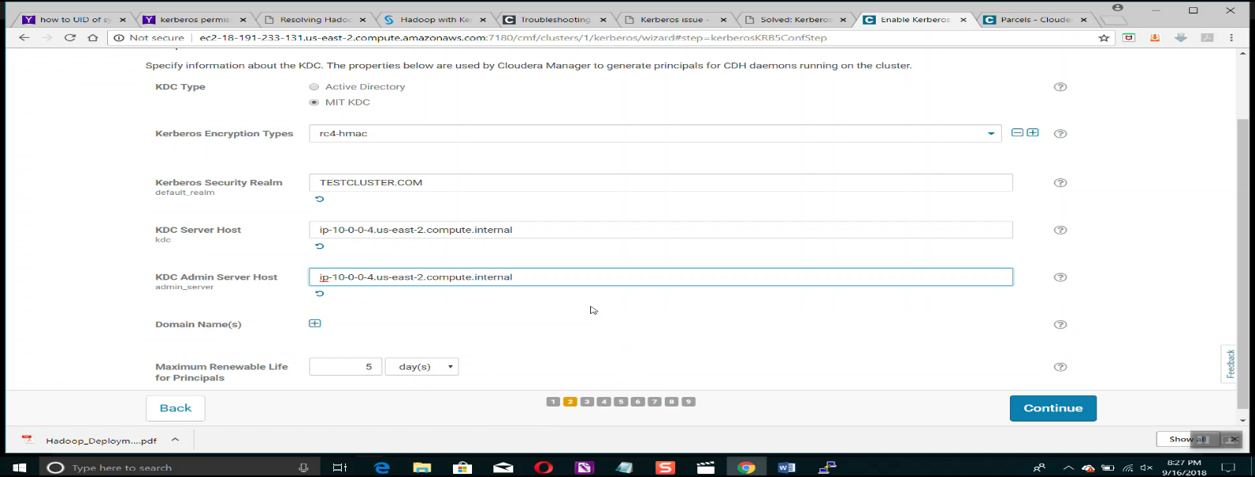

**Setup kdc account for cloudera manager server:**

**Username : coudera-scm**

**Password: <password>**

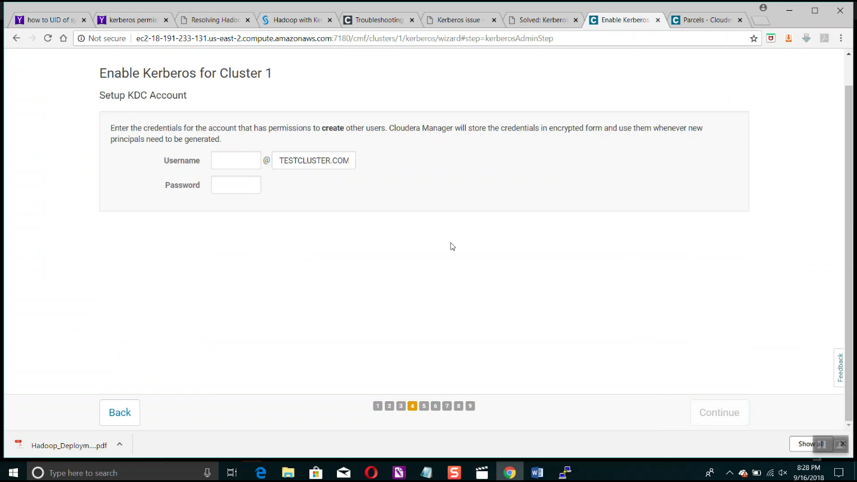

**Select for which services u need Kerberos enabled and generate keytabs accordingly*:***

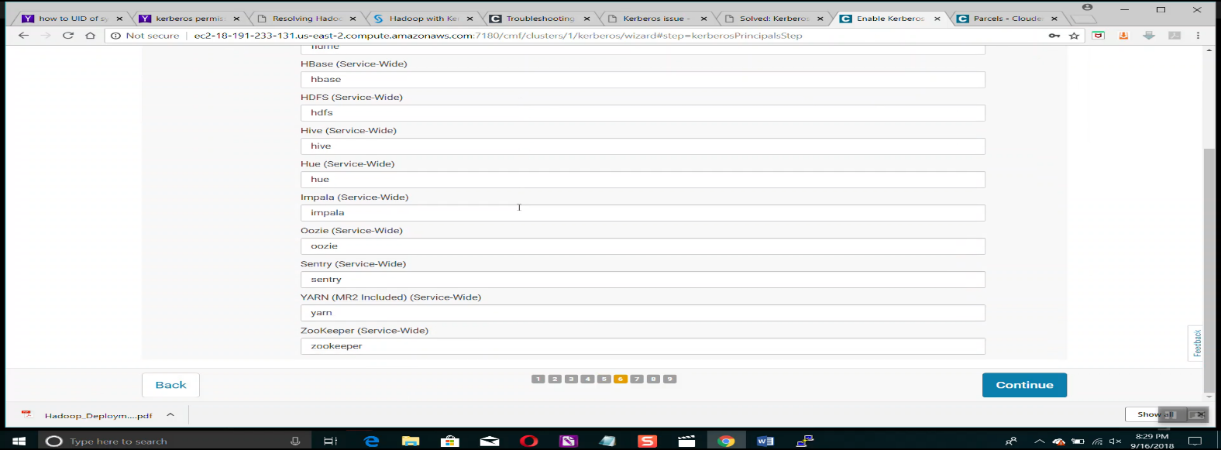

**Configure port for secure HDFS service on datanodes:**

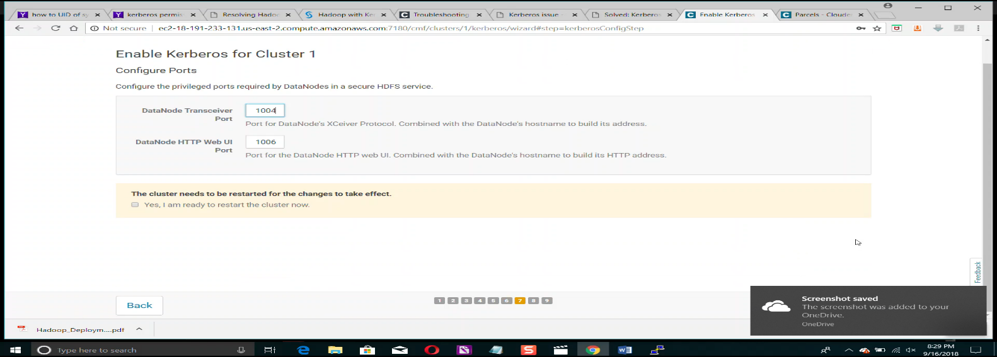

**By clicking next Kerberos will be enabled and cluster will be restarted automatically:**

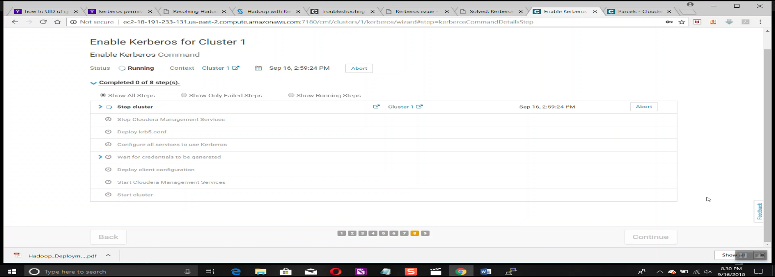

**For enabling Kerberos HA we just need to configure another Kerberos server and add the kdc server to krb5 configuration snippet in cloudera Kerberos configuration and restart services. Thereby Kerberos HA will be enabled.**

**Adding Services to Cluster:::::**

**Click on cluster>>add service>> select the service to add>> select hosts on which u want to install >> modify configurations if need any >> start the service along with stale configurations.**